DATABASE
labaratory work 5
Task 1: Add a CHECK constraint to passenger table to provide that passengers must be at least 10 years old.
ALTER TABLE passenger ADD CONSTRAINT age_check
CHECK (date_of_birth <= (CURRENT_DATE - INTERVAL '10 years'))
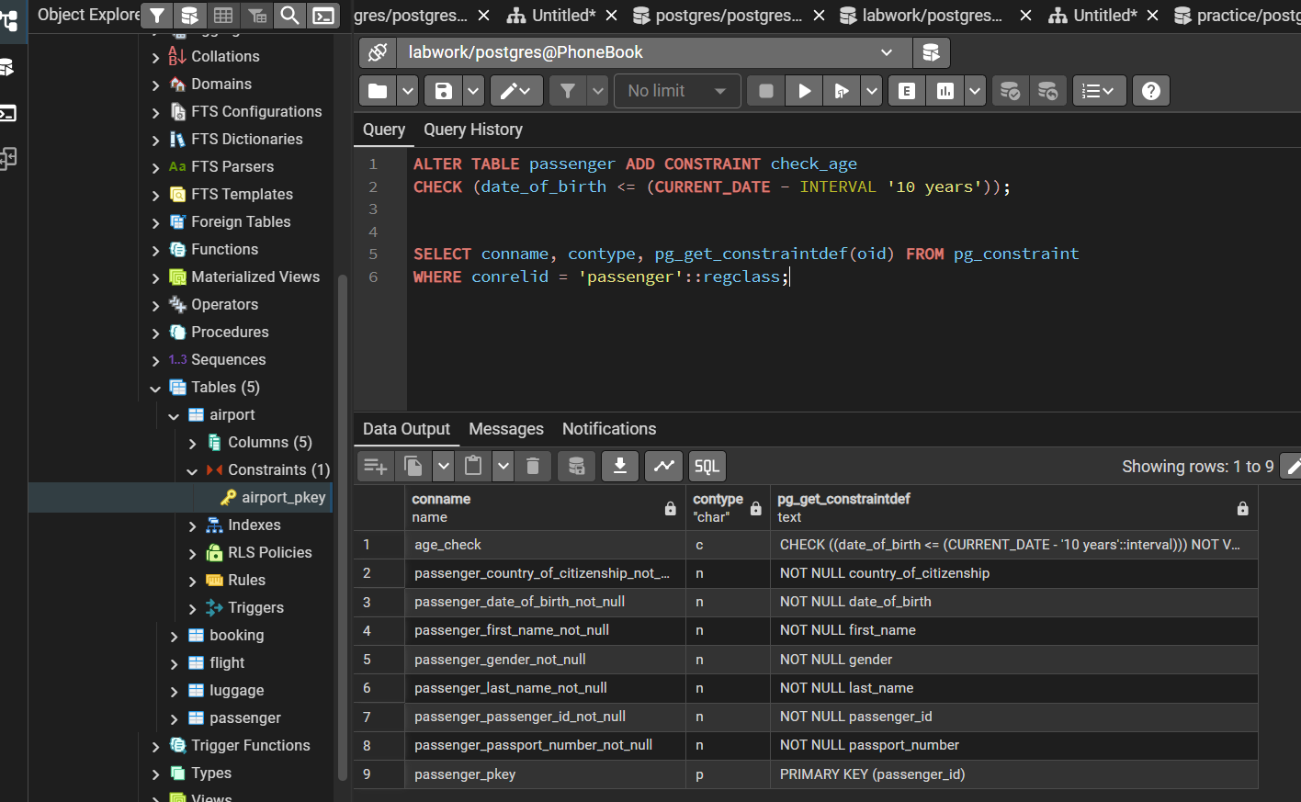
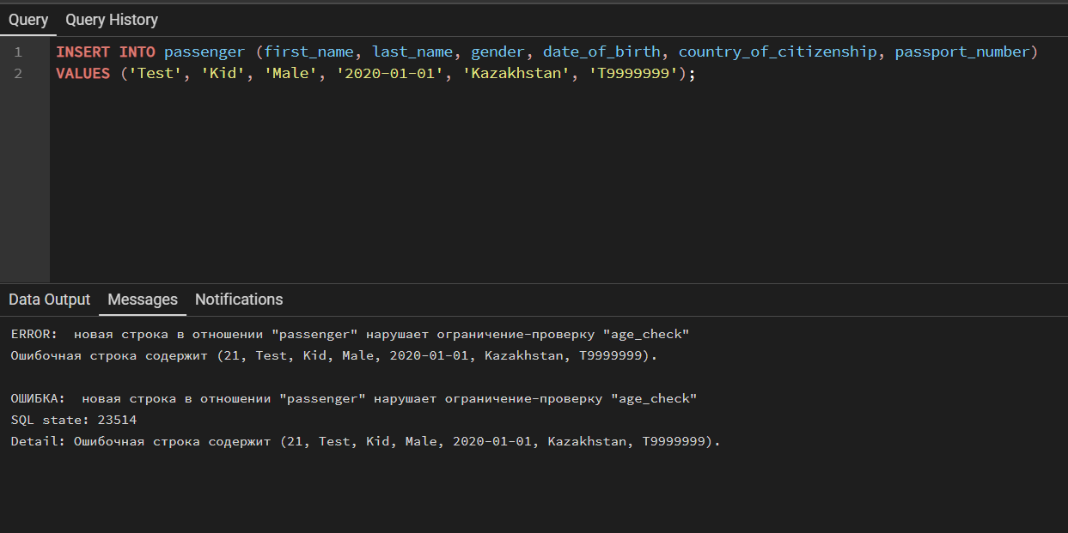

Task 2: Add a CHECK constraint to accept values in booking price not more than 50000tg and less than 0tg.
ALTER TABLE booking ADD CONSTRAINT book_price_check
CHECK (booking_price >= 0 AND booking_price <= 50000)
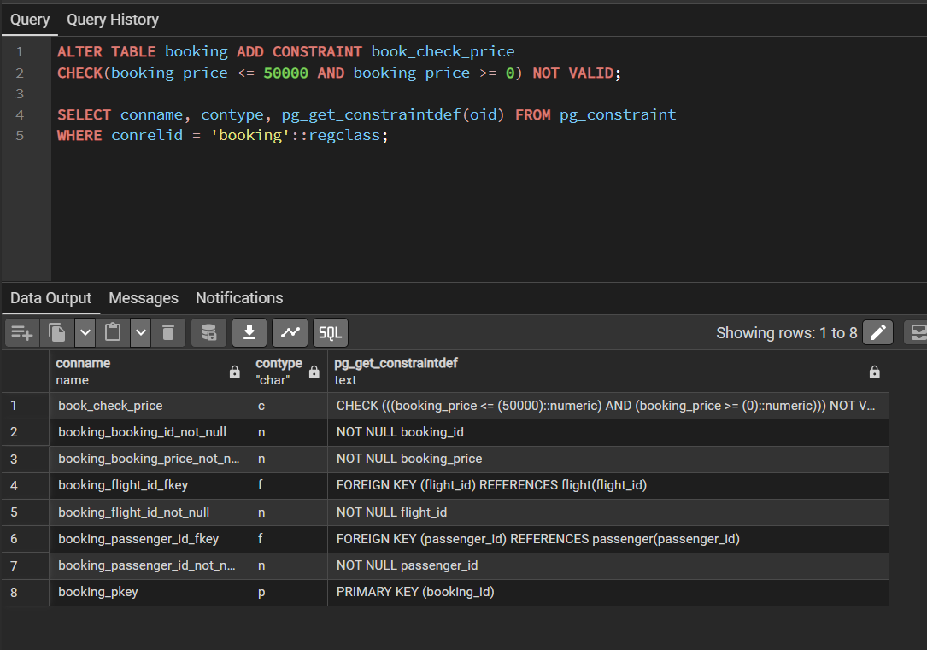
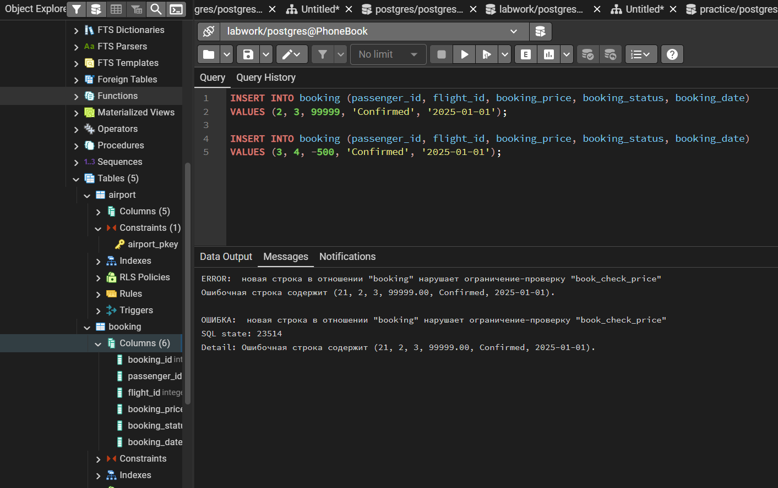

Task 3: Add a CHECK constraint to accept the luggage weight between 1 and 23 kg.
ALTER TABLE luggage ADD CONSTRAINT check_weight
CHECK (luggage_weight BETWEEN 1 AND 23)
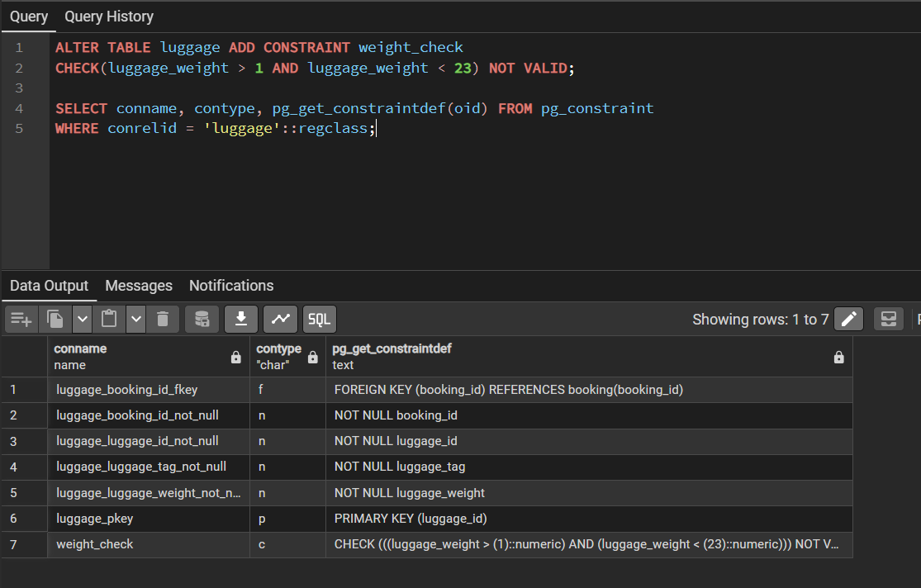
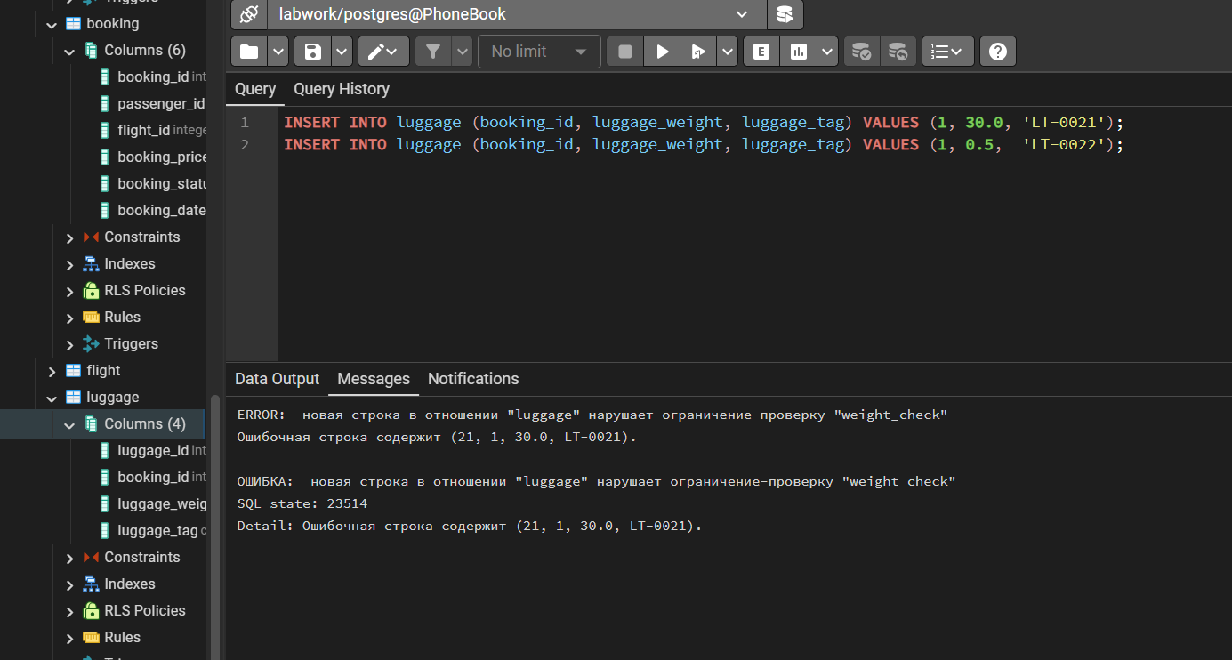

Task 4: Add a CHECK constraint to ensure that all values in airport_name must have at least 10 characters.
ALTER TABLE airport ADD CONSTRAINT chk_airport_name_len
CHECK (char_length(airport_name) >= 10)
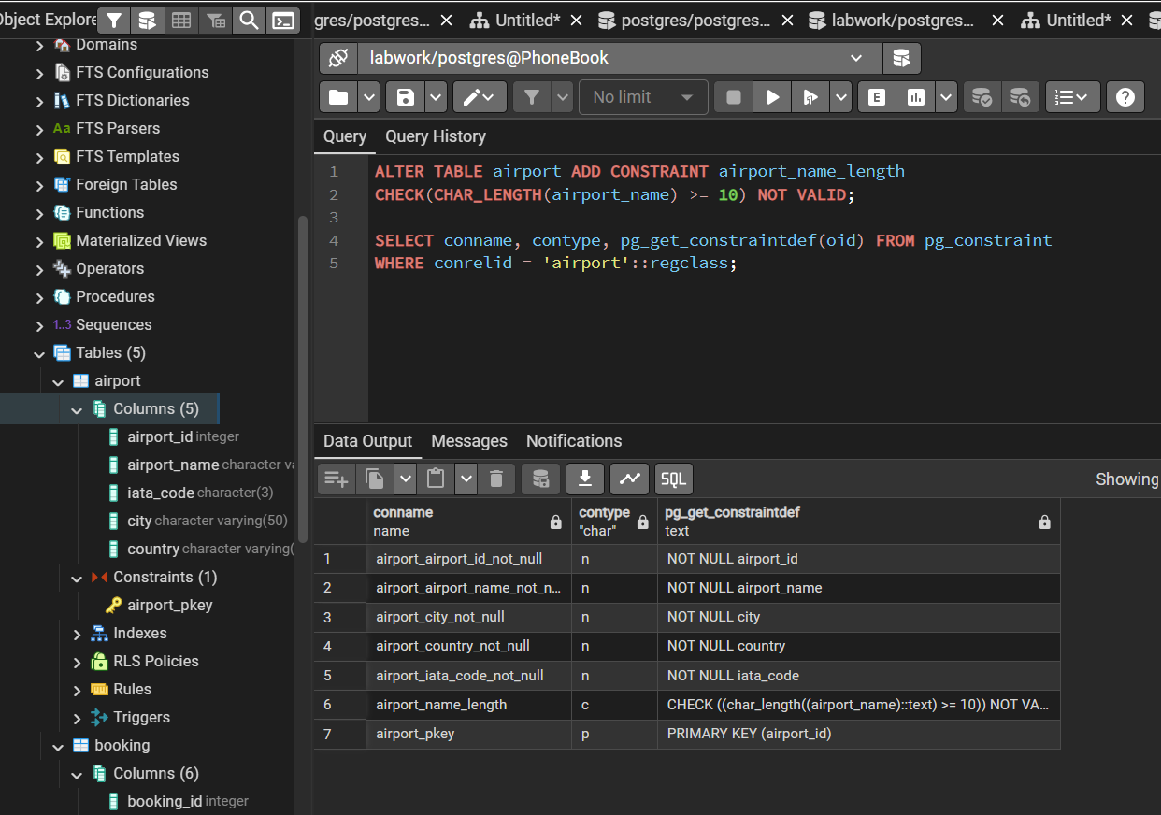
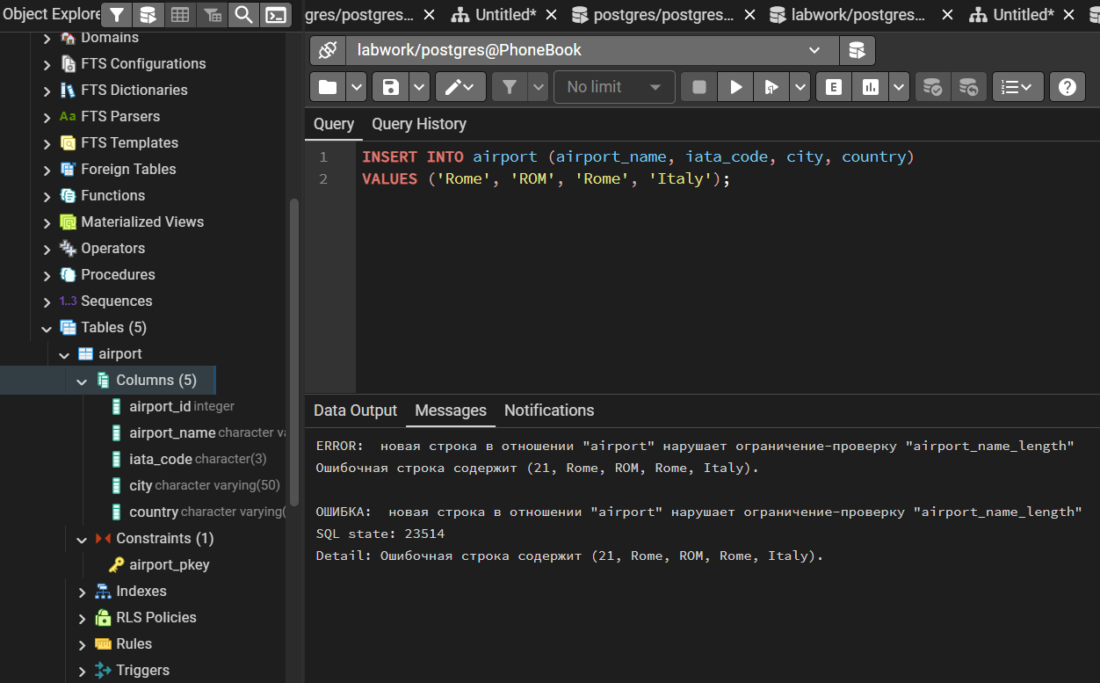

Task 5: Add UNIQUE constraint to some columns in each table in database.

ALTER TABLE passenger ADD CONSTRAINT uq_passport UNIQUE (passport_number);
ALTER TABLE airport ADD CONSTRAINT uq_airport_name UNIQUE (airport_name);
ALTER TABLE airport ADD CONSTRAINT uq_airport_iata UNIQUE (iata_code);
ALTER TABLE luggage ADD CONSTRAINT uq_luggage_tag UNIQUE (luggage_tag);
ALTER TABLE booking ADD CONSTRAINT uq_booking_pass_flight UNIQUE (passenger_id, flight_id);
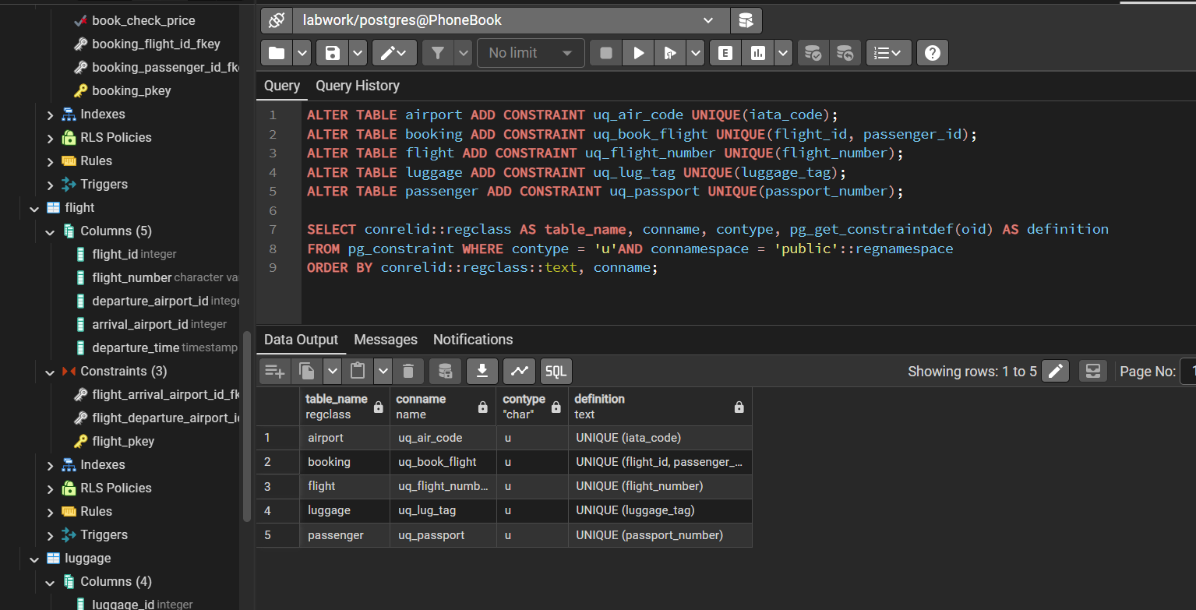
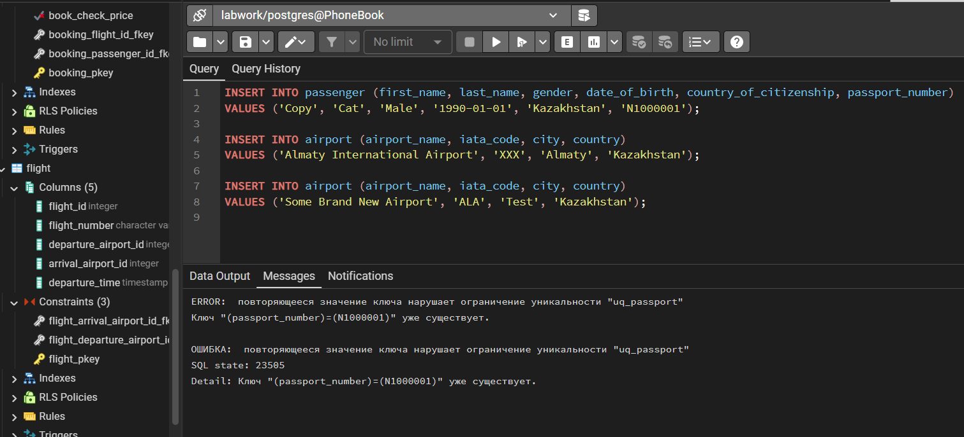

Task 6: Add a CHECK constraint to ensure that male passengers must be at least 18 years old and female passengers must be 19 years old.

ALTER TABLE passenger ADD CONSTRAINT chk_gender_min_age
CHECK (
(gender = 'Male' AND date_of_birth <= CURRENT_DATE - INTERVAL '18 years') OR
(gender = 'Female' AND date_of_birth <= CURRENT_DATE - INTERVAL '19 years'))
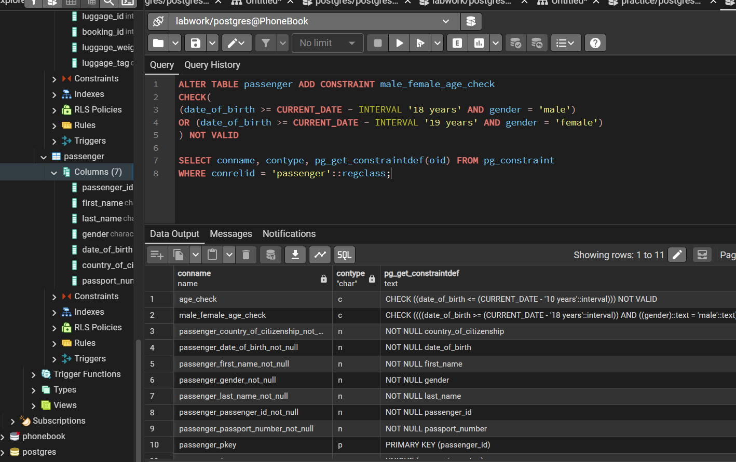
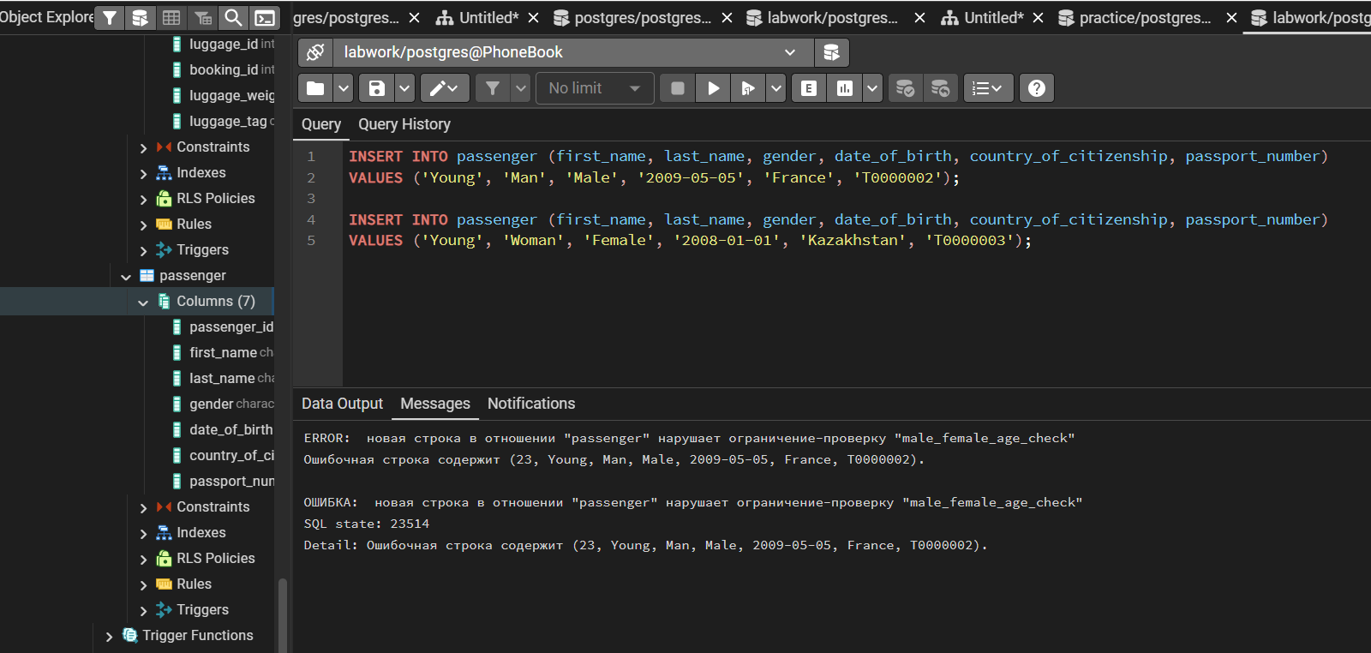

Task 7: Add a CHECK constraint to add rule as follow (use column country_of_citizenship):
- Passengers from Kazakhstan must be at least 18 years old.
- Passengers from France must be at least 17 years old.
- Passengers from other countries must be at least 19 years old.
ALTER TABLE passenger ADD CONSTRAINT pass_age_rest
CHECK(
(country_of_citizenship = 'Kazakhstan' AND date_of_birth <= CURRENT_DATE- INTERVAL '18 years') OR
(country_of_citizenship = 'France' AND date_of_birth <= CURRENT_DATE- INTERVAL '17 years') OR
(date_of_birth <= CURRENT_DATE- INTERVAL '19 years')
)
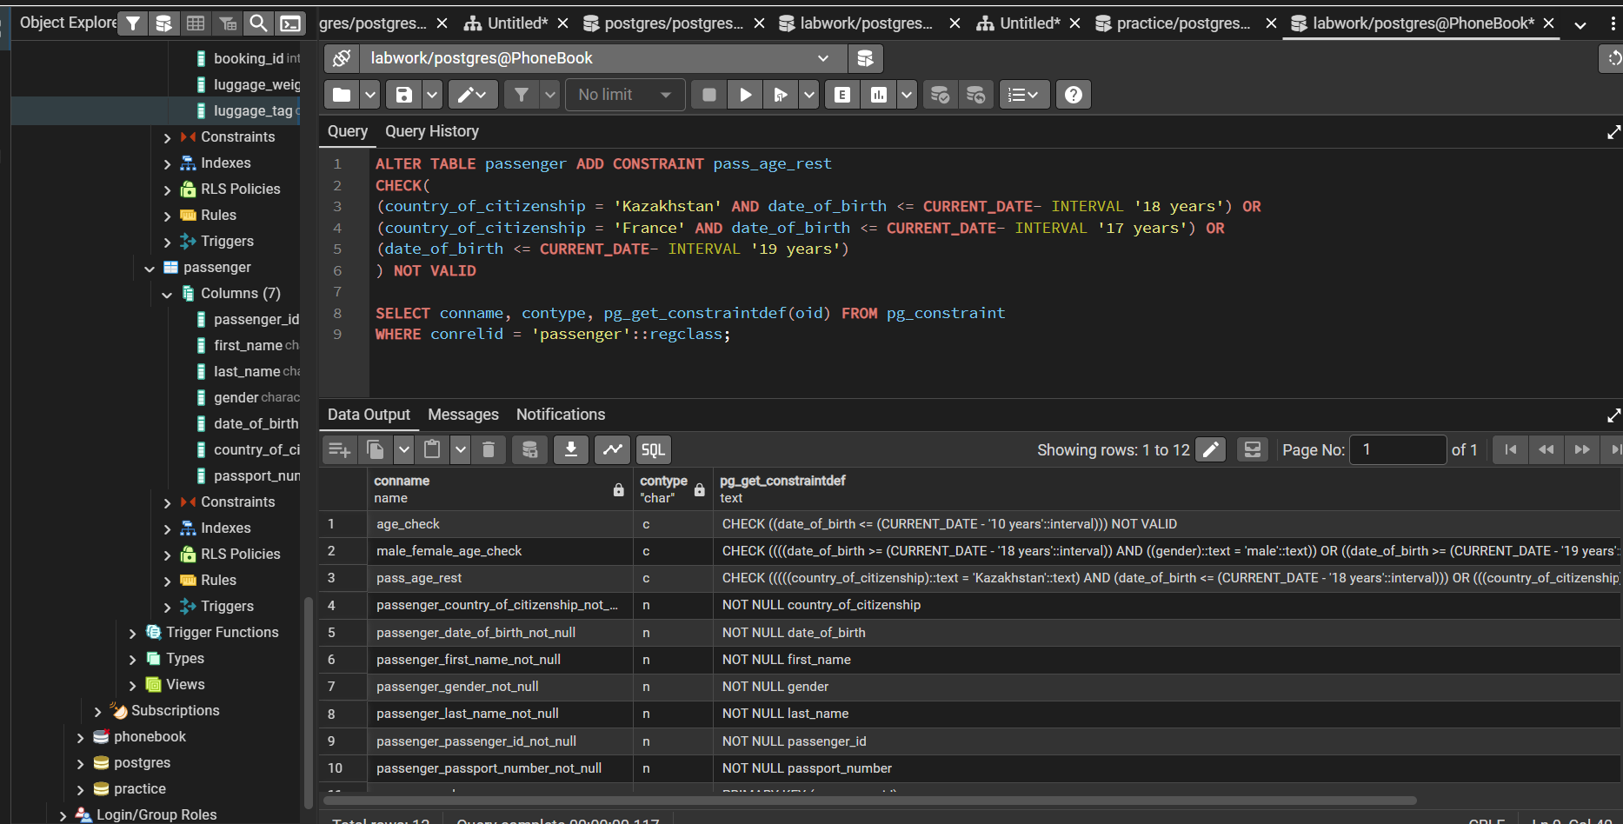
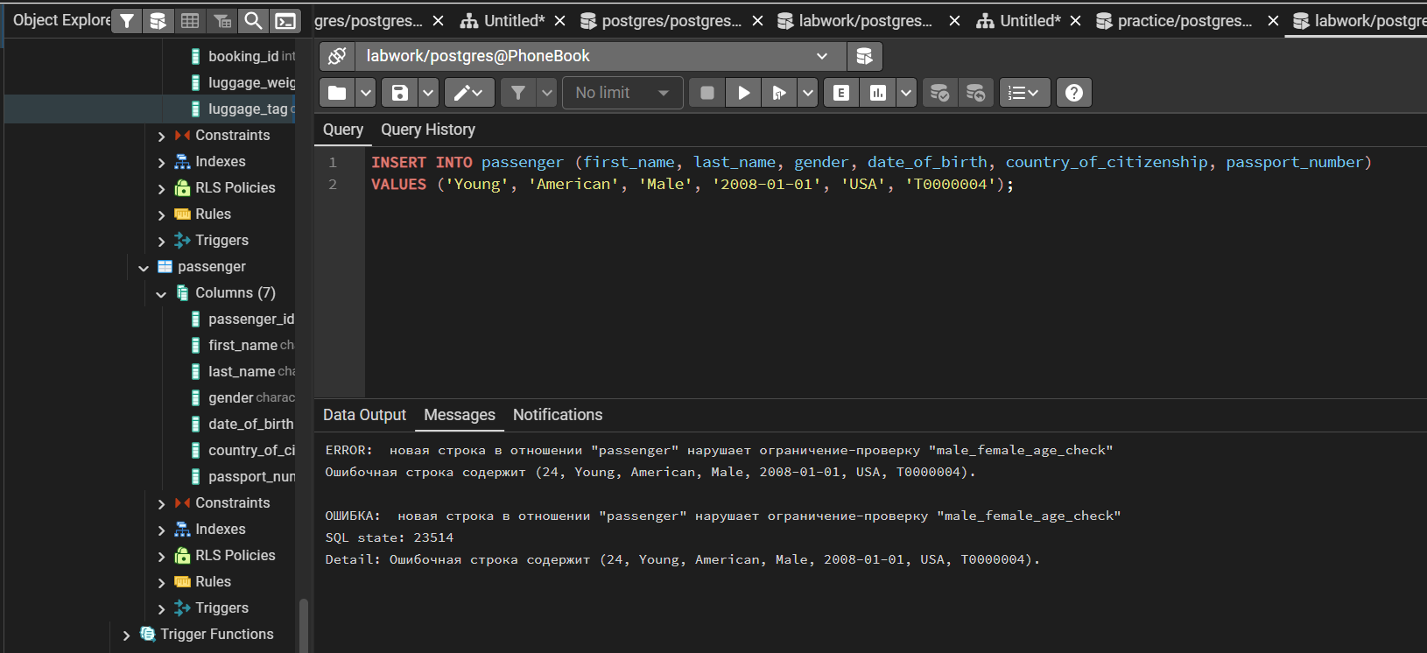

Task 8: Add a ticket_discount column to table booking and a CHECK constraint to apply some discount based on ticket price and created time:
- the constraint applies a 5% discount for tickets created after 2024-01-01,
and 10% discount for tickets created before 2024-01-01.

ALTER TABLE booking ADD COLUMN ticket_discount NUMERIC(10,2);

-- сначала заполняем существующие строки, иначе CHECK не добавится
UPDATE booking SET ticket_discount = ROUND(
CASE WHEN booking_date > DATE '2024-01-01'
THEN booking_price * 0.05
ELSE booking_price * 0.10
END, 2);
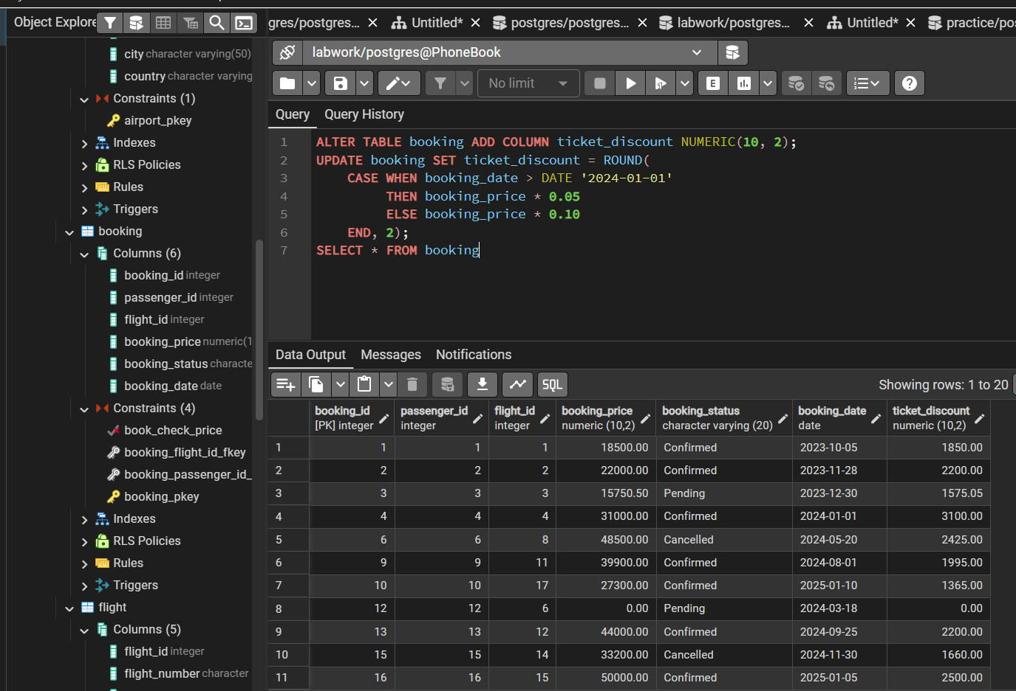

ALTER TABLE booking ADD CONSTRAINT chk_ticket_discount
CHECK (
ticket_discount = ROUND(
CASE WHEN booking_date > DATE '2024-01-01'
THEN booking_price * 0.05
ELSE booking_price * 0.10
END, 2)
);
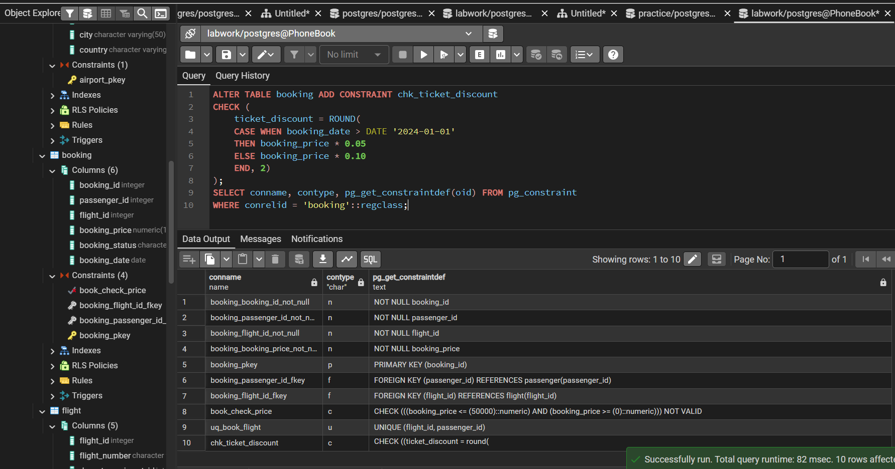

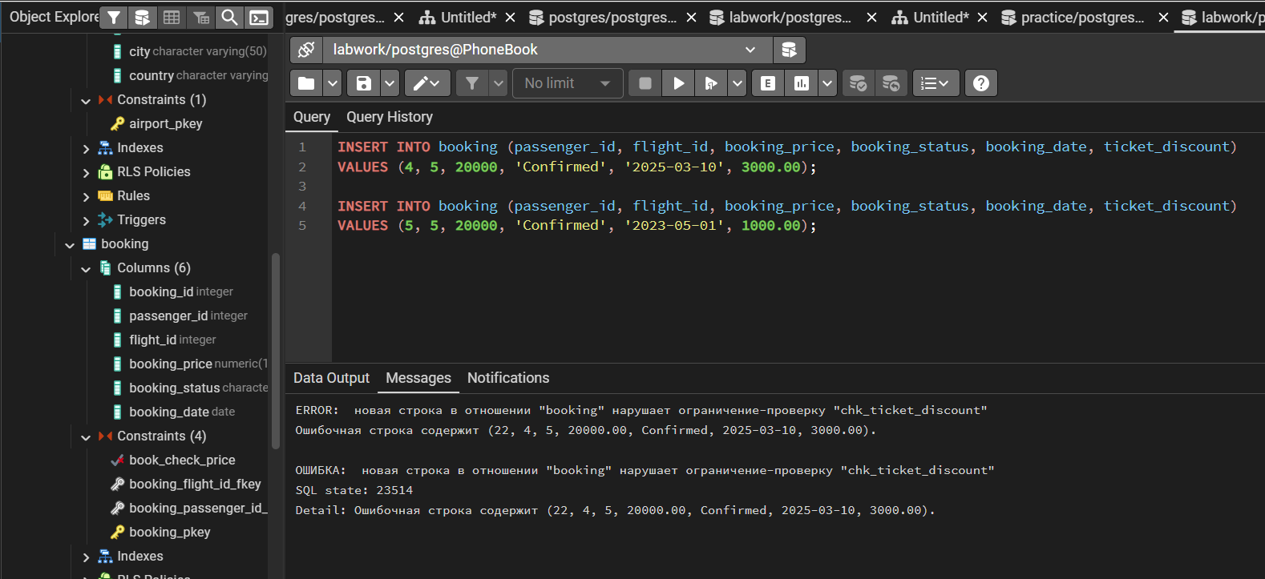

Task 9: Modify the booking table so that the booking status column has a default value of 'Confirmed'. Then insert a new booking without specifying booking status.

ALTER TABLE booking
ALTER COLUMN booking_status SET DEFAULT 'Confirmed';

INSERT INTO booking (passenger_id, flight_id, booking_price, booking_date, ticket_discount)
VALUES (1, 1, 20000, DATE '2025-03-10', 1000.00);

SELECT * FROM booking ORDER BY booking_id DESC LIMIT 1
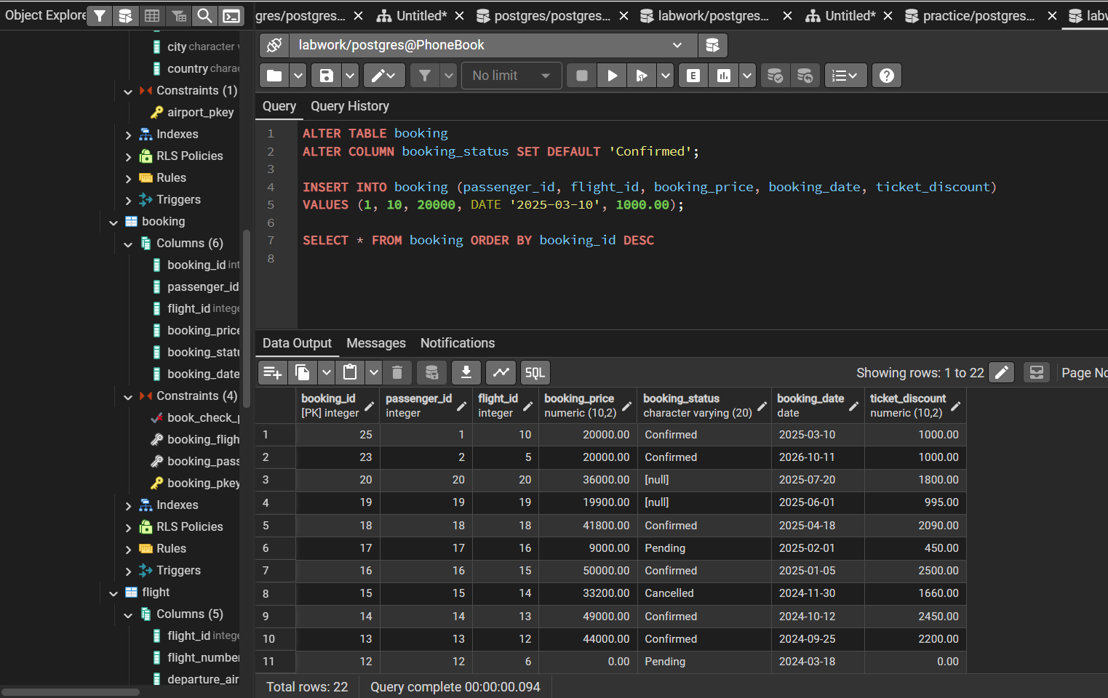

Task 10: Modify the appropriate date column in the database so that when a new record is inserted, the date is automatically set to the current date.

ALTER TABLE booking
ALTER COLUMN booking_date SET DEFAULT CURRENT_DATE
